AIM: Simulate Linear Convolution and Circular convolution on discrete time signals

LINEAR CONVOLUTION

import numpy as np

import matplotlib.pyplot as plt

x = np.array([1, 2, 3, 4, 5])

h = np.array([2, 4, 6, 8, 10])

y = np.convolve(x, h)

plt.stem(y)

plt.title('Linear convolution')

plt.xlabel('n')

plt.ylabel('y[n]')

plt.grid(True)

plt.show()

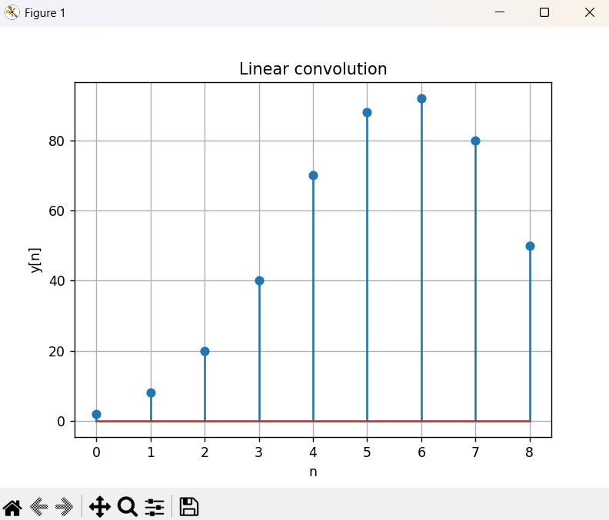

CIRCULAR CONVOLUTION

import numpy as np

import matplotlib.pyplot as plt

x = np.array([1, 2, 3, 4, 5])

h = np.array([2, 4, 6, 8, 10])

N = len(x) + len(h) - 1

X = np.fft.fft(x, N)

H = np.fft.fft(h, N)

y = np.fft.ifft(X * H)

plt.stem(y.real)

plt.title('Circular convolution')

plt.xlabel('n')

plt.ylabel('y[n]')

plt.grid(True)

plt.show()

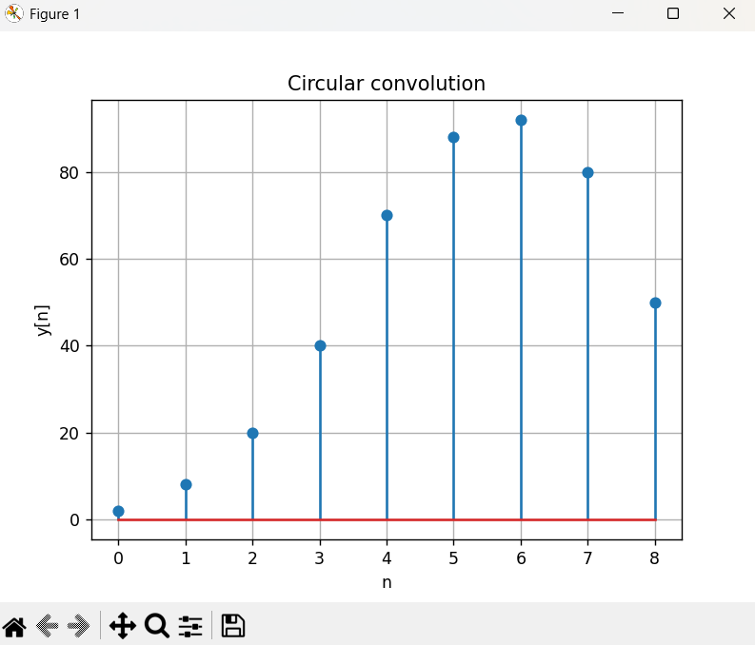

LINEAR AND CIRCULAR CONVOLUTION

import numpy as np

import matplotlib.pyplot as plt

def linear_convolution(signal1, signal2):

linear = np.convolve(signal1, signal2, mode='full')

return linear

def circular_convolution(signal1, signal2):

fft_length = len(signal1) + len(signal2) - 1

fft_signal1 = np.fft.fft(signal1, fft_length)

fft_signal2 = np.fft.fft(signal2, fft_length)

circular = np.fft.ifft(fft_signal1 * fft_signal2)

return circular

signal1 = np.array([1, 2, 3, 4, 5])

signal2 = np.array([2, 4, 6, 8, 10])

linear_con = linear_convolution(signal1, signal2)

circular_con = circular_convolution(signal1, signal2)

plt.figure(figsize=(10, 6))

plt.subplot(2, 1, 1)

plt.stem(linear_con)

plt.title('Linear conv.')

plt.xlabel('sample')

plt.ylabel('amplitude')

plt.subplot(2, 1, 2)

plt.stem(circular_con.real)

plt.title('Circular conv.')

plt.xlabel('sample')

plt.ylabel('amplitude')

plt.tight_layout()

plt.show()

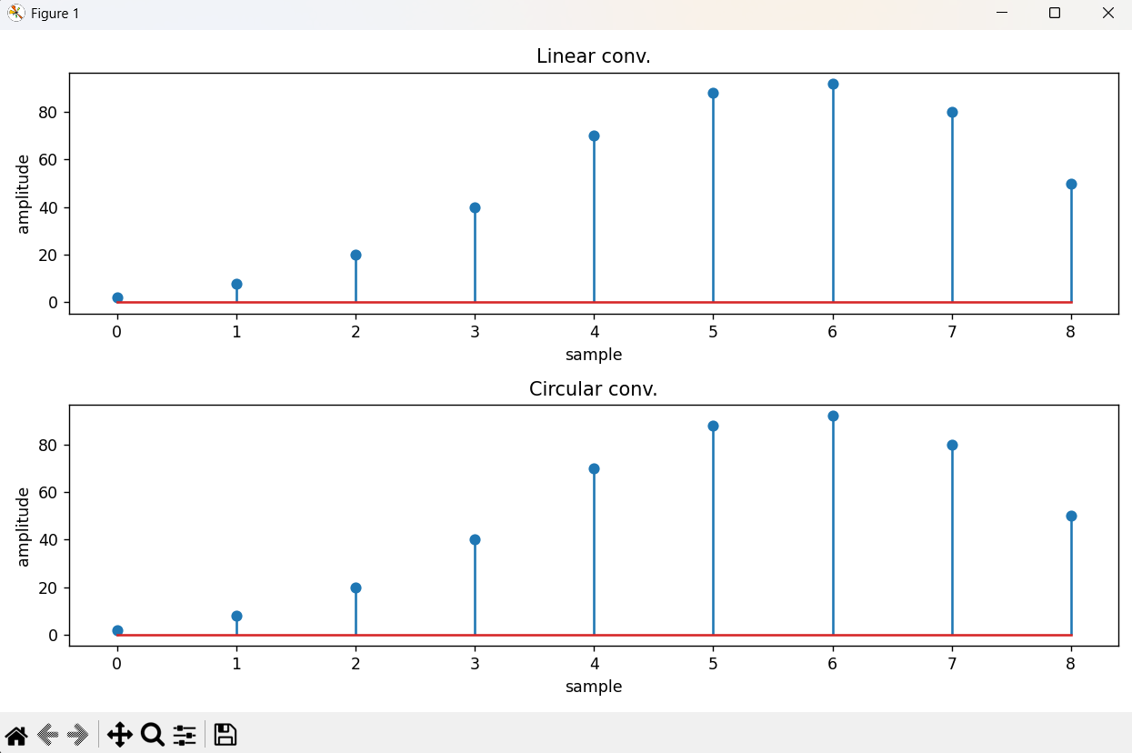

CONCLUSION

In this experiment, we successfully simulated both linear and circular convolution of discrete-time signals using Python. The NumPy library was used to perform the convolution operations, while Matplotlib was used to visualize the resulting signals. By comparing the two outputs, we understood how linear and circular convolution differ and how convolution can be implemented practically for discrete-time signals.

